Driving and Parking Directions: Quint State 2014
Hi! Welcome to the University of Tennessee in Knoxville, TN! If you have never been here, parking around campus can be a bit tricky. These instructions are designed to help make the process a little smoother.

Instructions for Thursday and Friday
On Thursday and Friday of Quint State, guest parking will be provided by the Volunteer Hall Guest Parking Garage. IMPORTANT – guests may only park on the 1st level of this garage using the entrance off of White Avenue. The address you can use to navigate to this entrance is:
1527 White Avenue
Knoxville, TN, 37916
This address may not take you directly to the entrance of the parking garage, but just keep going and look for signs that say “Visitor Parking”. Note – if you just put “Volunteer Hall Parking Garage” as your destination, it will take you to the wrong entrance, so please use the White Avenue address to help you get there. Hint – if you end up on Clinch Avenue, you’re at the wrong entrance.

To access the parking garage, you will take a parking ticket from the machine and can then access the garage and find yourself a parking spot. Once you have your parking ticket, you will need to present this to one of the hosting students from UTK to get a parking validation sticker and sign the parking sign-in sheet (for auditing purposes). On Thursday night, you will be going to the Down Under Recreation Center in the University Center, which, according to google maps, is a 2 minute walk. Here is a link to walking instructions, and here is a map with the specified locations:
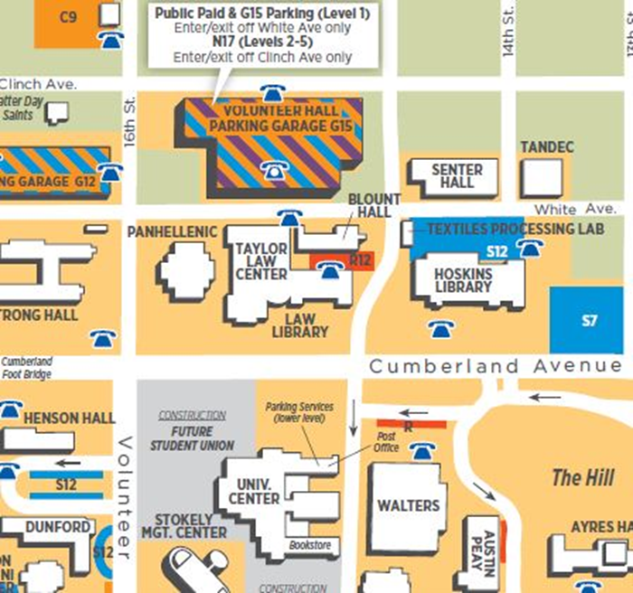

Down Under recreation is located on the first floor of the University Center, which is one level down from the main entrance. There is an information desk at the main entrance of the UC that can help direct you if you have trouble.

On Friday morning, you will follow the same parking procedures using the same parking garage as outlined above. After parking, you will then walk to the Black Cultural Center – an 11 minute walk (not counting waiting for the lights to change). The address for the Black Cultural Center is 1800 Melrose Avenue. Walking directions from Volunteer Hall to the BCC are available here, and here is a map with visual instructions:
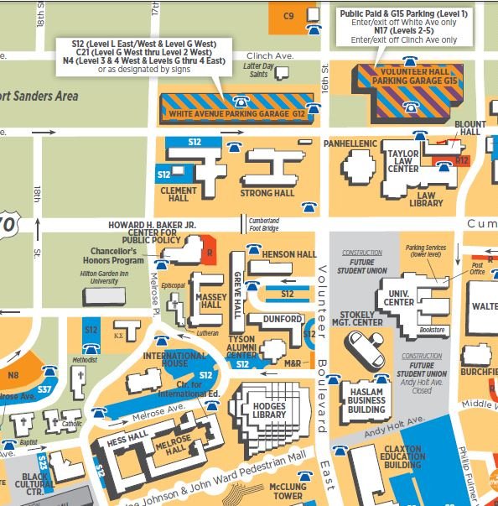

Instructions for Friday Night
On Friday night, we will be having a combined Student/Faculty/Staff social event at the Ijams Nature Center in Knoxville. The address you will need to navigate to this location is:
2915 Island Home Ave
Knoxville, TN 37920
If you do not have access to GPS or other navigation, please look up driving instructions from your host’s home (or wherever you will be coming from) to the above address ahead of time. Note that when you arrive at the address and turn into the parking lot, you will make a right and drive until you reach parking nearest to the Visitor’s center. Upon entering through the main doors of the Visitor’s center, you will find the entrance to the meeting room to the left of the main front desk.

Instructions for Saturday
The Saturday portions of Quint State will be held in the Bailey Education Complex. The official address for Bailey is:
Jane and David Bailey Education Complex
1126 Volunteer Blvd.
Knoxville, Tennessee
37996-3442
You are welcome to park at the meters (free on Saturdays) in front of Bailey, but you also are welcome to park in the staff parking lot S9 as pictured below, which you would access from Peyton Manning Pass:

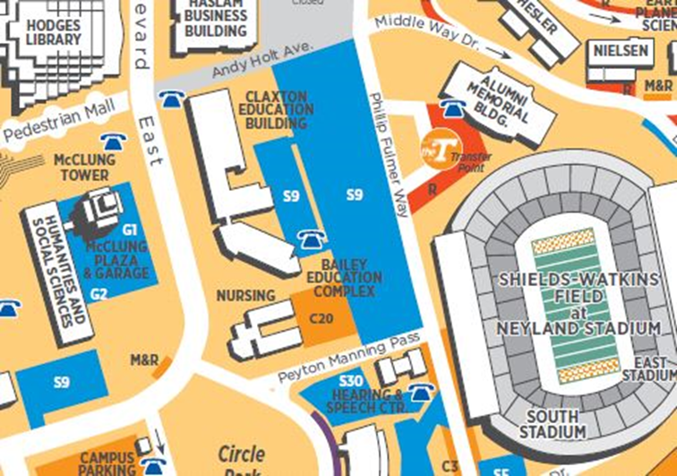

Enter here

Please note that the Claxton Education Building is a separate building from Bailey. As indicated in the circled portion on the map above, the Saturday sessions will be held in that triangular portion of the building on the second floor. We will attempt to provide signs and other assistance to help you find your way.

If you find yourself lost or confused with directions at any point, please call or text Rhett at (714) 717-1098.

